**44-560 Advanced Topics in Database Systems**

**Assignment 03: SQL Review**

Given below is the ER diagram of all sales in the Macy’s stores all over the US:

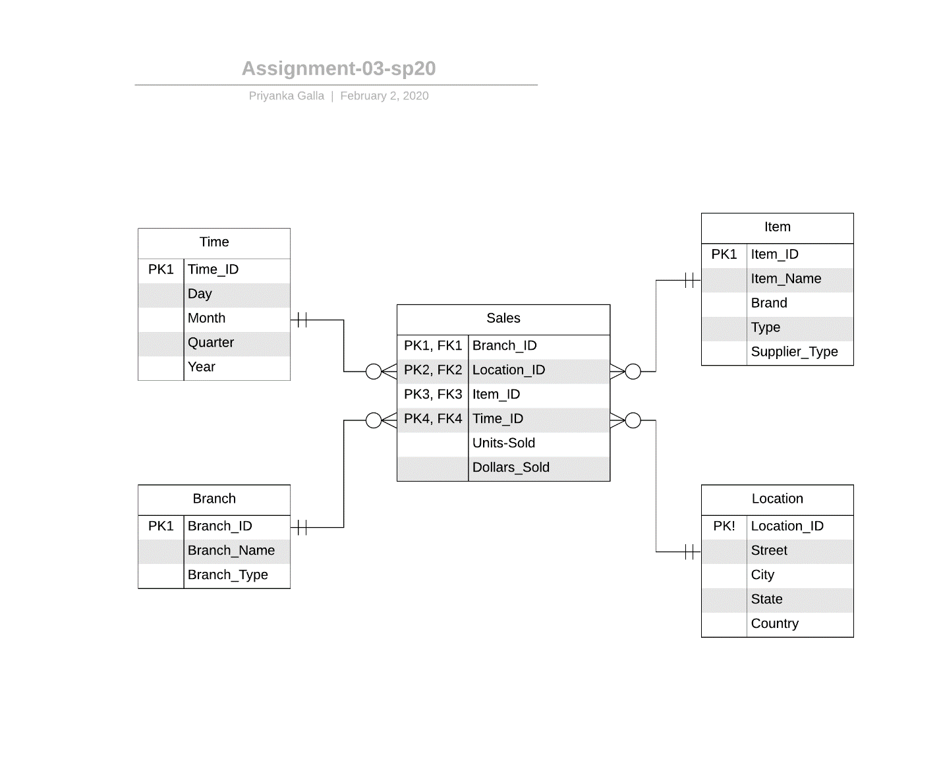

**Generate one Lastname_A03.sql file that can be run in SQL Developer. Identify each answer with comments indicating the question number.**

In the .sql file that you created, write the SQL statements for the following and execute them:

1. Create all the tables and relationships (including all primary keys, foreign keys, attributes and appropriate data types) shown in the ER diagram above.
2. Insert 3 records into each table. In the Item table, consider the first record as your favorite dress, second record as a gift that you have recently bought to someone, and the third record as your most favorite accessory that you are currently using; then insert the appropriate data. Similarly, insert some valid data into the other three tables.
3. Write an SQL statement to alter the Sales table such that the data types of Units_Sold and Dollars_Sold attributes are NUMBER(50) and NUMBER(200).
4. Write an SQL statement to update the third row of Item table: Item_Name as ‘Hat’, Brand as ‘Puma’, and Type as ‘Ferrari’.
5. Write an SQL statement to display the Branch_ID, Location_ID, Item_ID, Units_Sold and Dollars_Sold of each customer. Results should be in a descending order of Item_ID.
6. Write an SQL statement that displays the number of items, the sum of units_Sold and the sum of dollars_sold in each location. (Hint: Use group-by).
7. Write an SQL statement to commit the database.
8. Write an SQL statement to display all the tables’ data separately. (Hint: Use select and display data separately for each table. No need to use any joins.)
9. Write an SQL statement drop all the tables that you have created in this assignment.
10. Write an SQL statement to rollback the database.
11. Write an SQL statement to display all the tables’ data separately. (Hint: Use select and display data separately for each table. No need to use any joins.)
12. If you get any data displayed in question-11, list the names of all the tables that got displayed and tell us why there is still data existing despite you dropping all the tables in question-09. (Please answer this in comments).

**To submit:**

Submit the .sql script file containing your answers that can be run in SQL Developer.